MEMO

**FROM:** Edward Ma, W0057568, 701

**TO:** Bill Cunningham

**DATE:** 12-2-2016

**SUBJECT**: DBAS 1001 Assignment #8

* **Existing System Details:**
  + The Appointment Scheduling System Design documentation from Assg4 using the following files
    - Assg7.accdb
* **Statement of Requirements**:
  + to complete each of the tasks listed in the “Your Work section of this assignment;” on the assg8.docx
* **Analysis:**
  + ERD and Data Dictionary Details on assg4.docx
  + 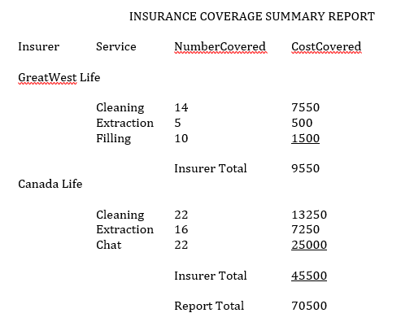Storyboard. Ex: What the client want the report to look like
  + SQL View:
    - SELECT p_insurer AS Insurer,

s_name AS Service,

SUM(as_quantity) AS [Number Covered],

SUM(as_quantity * s_costperunit) AS [Cost Covered]

FROM service INNER JOIN

(person INNER JOIN

(appointment INNER JOIN app_svc

ON appointment.a_id = app_svc.as_a_id)

ON person.p_id = appointment.a_p_id)

ON service.s_id = app_svc.as_s_id

GROUP BY p_insurer, s_name;

* + Using the Report Wizard
    - 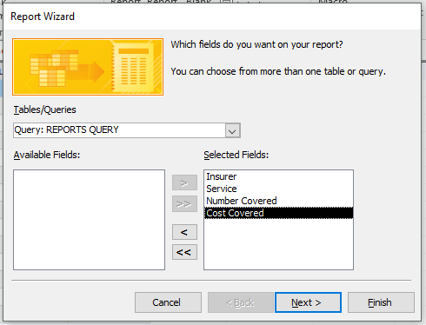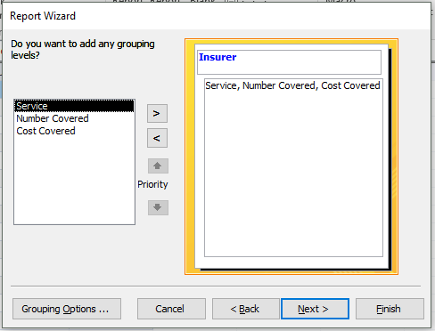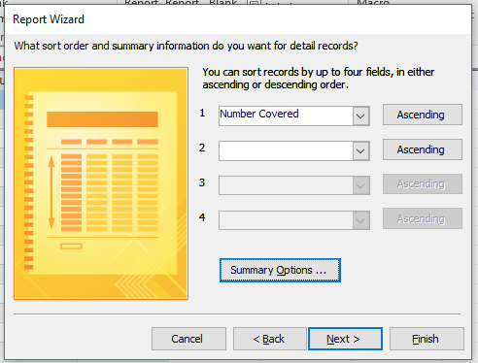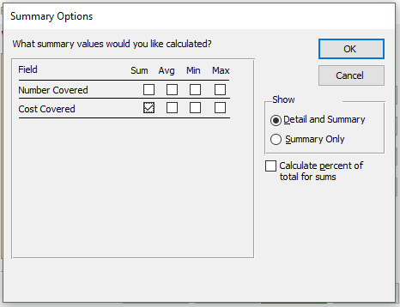With Step by Steps instruction!
    - 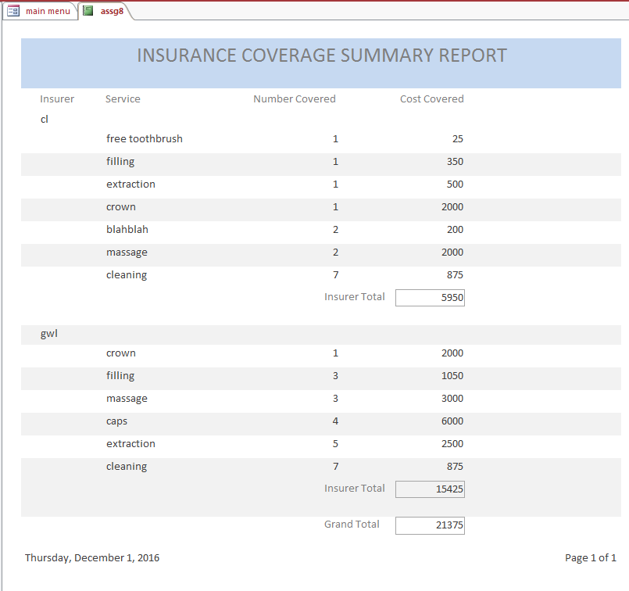Final Product
* **Recommendation:**
  + Please accept the demonstration as evidence of the per-specification functionality of the data entry application.